The goal of this competition is the prediction of the price of diamonds based on their characteristics (weight, color, quality of cut, etc.), putting into practice all the machine learning techniques you know.

Evaluation

The evaluation metric chosen for this competition is the RMSE (Root Mean Squared Error):

<https://www.statisticshowto.com/probability-and-statistics/regression-analysis/rmse-root-mean-square-error/>

Train a minimum of 4 different models

Perform Feature Extraction and Engineering techniques

Documentation needed to reproduce the code

The code in .py and/or .ipynb files that allows to reproduce the exercise.

Functions must be in modules. ;)

The Readme must contain a summary of the machine learning tools and algorithms

and the results or the score obtained with each of them.

Features

id: only for test & sample submission files, id for prediction sample identification

price: price in USD

carat: weight of the diamond

cut: quality of the cut (Fair, Good, Very Good, Premium, Ideal)

color: diamond colour

clarity: a measurement of how clear the diamond is

x: length in mm

y: width in mm

z: depth in mm

depth: total depth percentage = z / mean(x, y) = 2 * z / (x + y) (43--79)

table: width of top of diamond relative to widest point (43--95)

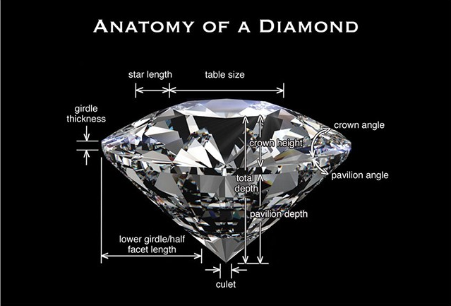

library(readr)

library(dplyr)

library(ggplot2)

library(ggcorrplot)

library(tidyr)

library(fastDummies)

library(caret)

train <- read_csv("C:/Users/prajw/Desktop/New folder/diamonds-datamad1021-rev/train.csv")

View(train)

# glimpse of diamond dataset

glimpse(train)

# summary of diamond dataset

summary(train)

# converting character variables to factors

train %>% mutate(cut = as.factor(cut),

color = as.factor(color),

clarity <- as.factor(clarity))

summary(train)

# bar plot on cut varaiable

ggplot(train, aes(x=cut, fill = cut)) + geom_bar() + theme_classic() + labs(title="Various types of diamond cuts", x="Cut categories", y = "Count")

# bar plot on clarity varaiable

ggplot(train, aes(x=clarity, fill = clarity)) + geom_bar() + theme_classic() + labs(title="Various types of diamond clarity levels", x="diamond clarity levels", y = "Count")

# Checking the distribution of depth column.

ggplot(train, aes(x = depth)) + geom_histogram(fill = 'blue', bins=100) + labs(x="depth", y="Count",title = "Probability Distribution of depth") + theme_classic()

# Checking the distribution of carat column.

ggplot(train, aes(x = log(carat))) + geom_histogram(fill = 'blue', bins=100) + labs(x="carat", y="Count",title = "Probability Distribution of carat") + theme_classic()

apply(train,2,function(x){any(is.na(x))})

# Correlation

train_cor <- round(cor(train %>% select_if(is.numeric)), 1)

ggcorrplot(train_cor, title = "Correlation", type = "lower") + theme(plot.title = element_text(hjust = 0.5), axis.text.x = element_text(angle = 90))

# since x, y, z is highly correlated to eachother and also it's highly correlated with caret variable, so removing from dataset

train <- train %>% select(-c(x,y,z))

# box plot for all numeric variables

train %>% select_if(is.numeric) %>% mutate_all(scale) %>% gather("features","values") %>% na.omit() %>%

ggplot(aes(x = features, y = values)) + geom_boxplot(show.legend = FALSE) + stat_summary(fun = mean, geom = "point", pch = 1) +

# Add average to the boxplot

scale_y_continuous(name = "Variable values", minor_breaks = NULL) + scale_fill_brewer(palette = "Set1") + coord_flip() + theme_minimal() + labs(x = "Variable names") + ggtitle(label = "Distribution of numeric variables in diamond train dataset")

# Converting category variable to numeric variable.

train_d <- dummy_cols(train)

train_d <- train_d %>% select(-c(cut, color, clarity))

View(train_d)

# Splitting dataset into training (60%) and validation (40%) sets

set.seed(23)

index <- createDataPartition(train_d$price, p=0.6, list = FALSE)

train_df <- train_d[index,]

test_df <- train_d[-index,]

# Defining a function to normalize the data.

scale_fun <- preProcess(train_df %>% select(-price), method = c("center", "scale"))

train_norm <- predict(scale_fun, train_df)

test_norm <- predict(scale_fun, test_df)

# Summary statistics of normalized data

summary(train_norm)

# Building a model to estimate the diamond price value

diamond_train_model <- lm(price ~ . , data = train_norm)

summary(diamond_train_model)

# Performance metrics on test data

# RMSE on test data

(linear_base_rsme <- sqrt( mean(( test_norm$price - predict( diamond_train_model, test_norm))^2)))

# R squared on test data

(linear_base_rsquare <- cor( test_norm$price, predict( diamond_train_model, test_norm))^2)